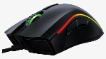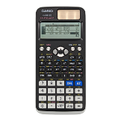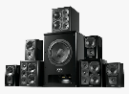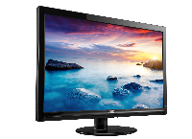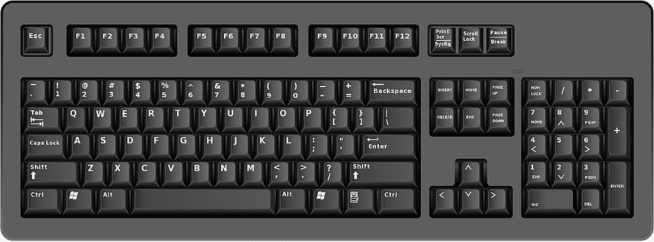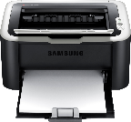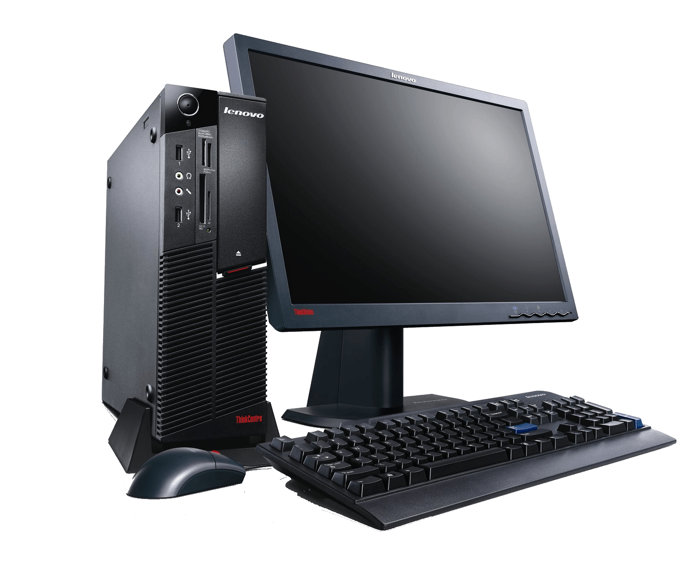

✕

✕

✕

✕

✕

✕

$40

$30

$60

$100

$180

$150

$40

$10

$30

$60

$140

$100

MOUSE

CALCULATOR

SOUND SYSTEM

MONITOR

KEYBOARD

PRINTER

%

OFF

50

APRIL-MAY 2016

SALE

BIG